**Lab 7: Maintain Technicians**

**(100 points)**

This project requires you to use of the TechSupport database provided with this assignment. You will need to have SQLExpress installed and running on your computer before you will be able to pull the TechSupport dataset into your Visual Studio project using the Data Source tools.

The design of the Technician Maintenance form

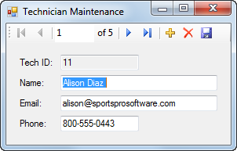

Operation

* When this application first starts, the data in the first row of the Technicians table is displayed. Then, the user can display the data for other rows using the navigation buttons in the toolbar.
* To modify an existing row, the user enters the modifications and then clicks the Save Data button in the toolbar.
* To delete an existing row, the user clicks the Delete button in the toolbar, followed by the Save Data button.
* To add a new row, the user clicks the Add New button in the toolbar, enters the data for the new row, and then clicks the Save Data button.

Specifications

* This application should handle SQL Server and ADO.NET exceptions.
* Because the TechID column is an identity column, don’t allow the user to change the value in this column.
* Limit the number of characters that can be entered into the Name, Email, and Phone text boxes so the entries don’t exceed the sizes allowed by the Name, Email, and Phone columns.